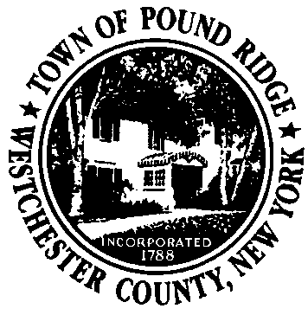

**Pound Ridge Economic Development Committee**

**Committee Charge:**

The Mission of the Pound Ridge Economic Development Committee is to promote, encourage, and support local businesses in Pound Ridge and make Pound Ridge an economically vibrant community where people work, shop, dine, and enjoy services and recreation in Pound Ridge. This will be accomplished by involving established business organizations, Town Government Boards and Commissions, and Town residents.

Committee members are charged with recommending a comprehensive strategy to the Town Board to:

1. Promote coordination and communication between and among:
2. Residents
3. Local Businesses
4. Town Government
5. Town boards/commissions especially planning, zoning, water commission, and the water/wastewater task force
6. Other towns.
7. Coordinate Community Calendar to maintain active content about the activities in Town that could promote commerce in our local business district.
8. Assist in the development of branding and active marketing to promote Pound Ridge small businesses and the Scotts Corners business district.
9. Recommend guidelines for the aesthetics of the Scotts Corners business district.
10. Recruit businesses and services to Pound Ridge which support the brand and as desired by residents.
11. Interact with and encourage existing and prospective business owners to develop a more vibrant business community.
12. Update the Town’s Website about the Pound Ridge Economic Development Committee and its services.
13. Deliver a report detailing the progress made towards promoting, encouraging, and supporting local businesses in Pound Ridge annually to the Town Board.

**Structure/Members:**

The Committee shall have 2 permanent positions reserved for representatives of the existing town business organizations, 4 Pound Ridge resident members at-large appointed by the Town Board, and 1 Town Board member appointed by the Town Board. There will be 2 Co-chairs. One Co-Chair will be the Town Board member and the other will be selected by the remaining members and confirmed by the Town Board. Co-Chairs for this committee will serve one-year terms and may be re-appointed by the Town Board each year. Committee members At-Large will serve 5- year terms.

The makeup of the Committee shall be as follows:

Co-Chairs:

Member At-Large

Town Board Member

2 Permanent Positions for Business District Representation:

One member from the Pound Ridge Partnership (selected and termed according to the rules of that organization)

One member from the Pound Ridge Business Association (selected and termed according to the rules of that organization)

4 At-Large Members

Pound Ridge residents representing relevant fields including real estate, marketing, development, law, finance, and other relevant fields, and having a general interest in the economic vitality of the Town’s businesses.

1 Member from the Town Board

The Town Board shall select one Town Board member to serve as a Co-Chair.

**Meeting Date:**

Meetings will be held on the [insert day of month-i.e. Second Tuesday of each month].

**Budget:** $1,000 annually for incidentals